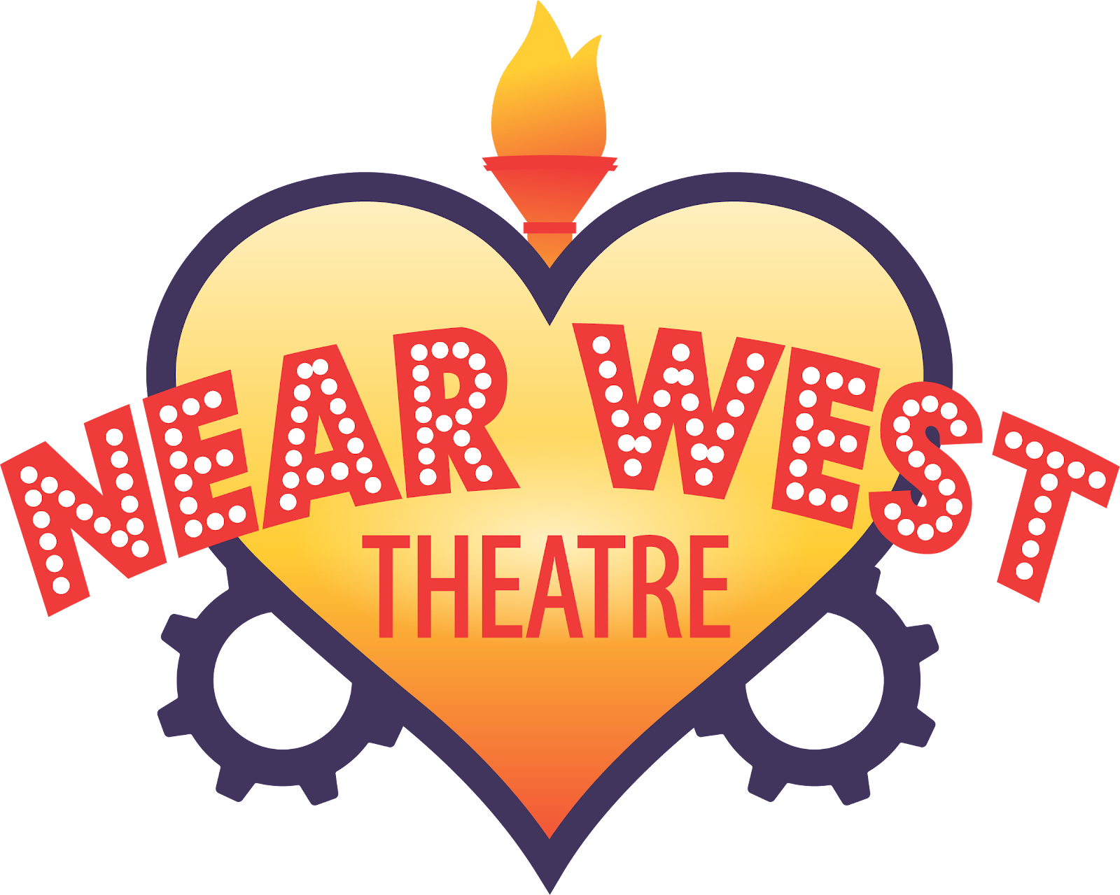

FOR IMMEDIATE RELEASE:
Contact: Hannah Armenta
Engagement Manager
Harmenta@nearwesttheatre.org
216-961-9750

Near West Theatre Reframes Next to Normal
Award-Winning Rock Musical Comes to Near West Theatre’s Black Box

CLEVELAND – August 20, 2025 – Near West Theatre is proud to present “Next to Normal,” a Pulitzer Prize and Tony Award-winning rock musical that dives into the inner workings of a family grappling with love, loss, and the challenges of mental illness. Running for two weekends, September 18-28, in Near West Theatre’s Black Box, this intimate production invites audiences to experience a story of struggle and resilience told through a fresh, vital perspective. Performances will take place at Near West Theatre’s ADA-compliant venue, located at 6702 Detroit Avenue in the heart of the Gordon Square Arts District. Tickets are $20, with additional Pay What You Choose options available. Visit nearwesttheatre.org or call the Box Office at 216-961-6391, weekdays from 11 a.m. to 4 p.m.

Traditionally staged with a white cast, “Next to Normal” at Near West Theatre will feature a predominantly Black and Brown ensemble. This artistic choice is both intentional and essential.

“It was important to me that we took this story that is so typically seen from one lens and shifted it into a different one,” shares Director, Kirk Eichelberger. “We don’t talk enough about Black and Brown mental health, but our struggles are the same as our white counterparts. This production highlights that reality.”

In today’s world, mental health is more openly discussed than ever before, yet stigma still lingers, especially in communities of color. “Next to Normal” brings those conversations into focus, showing that while the experiences of mental illness are deeply personal, they are also universally human.

“We all struggle in different ways, but just because we may look different from you doesn’t mean that our struggles are drastically different,” says Eichelberger. “Taking the opportunity to really get to know someone, past what’s on the surface, can change how we respond and connect with one another.”

Though “Next to Normal” does not shy away from portraying the weight of mental illness, it also illuminates the possibility of healing and resilience.

“Audiences should come see ‘Next to Normal’ because it’s a beautiful story told in a way that might allow you to see it from a different perspective,” says Artistic Director, Trinidad Snider. “Yes, it’s about a family struggling, but it’s also about their willingness to fight to get to the other side. I think that’s such a relatable thing, especially in a 2025 world where so many of us are learning to cope and find the light in the darkness.”

Presented with support from Birthing Beautiful Communities, Ohio Arts Fund, & the United Black Fund, “Next to Normal” boasts a stellar creative team. Directed by Kirk Eichelberger with Music Direction by Bryan Bird, the production team also features Lighting Design by Michael Stein, Scenic Design by Perren Hedderson, and Costume Design by Mia Jones. Near West’s production will feature Sound Design Sound by James Romeo with Technical Direction by Perren Hedderson and Assistant Technical Direction by Emily Hehnen. Near West’s Production Manager is Michael Stein and "Next to Normal” will be Stage Managed by Tyree Franklin with Assistant Stage Management offered by Carmen Chen.

The talented cast includes (in alphabetical order): Kyla Burks, Mira Cahalane, Isaac Cook, Carlos Cruz, Roman Kline-Bossman, Joshua McElroy, Mary Francis Miller, Emily Morgan, Akemonte Roberson, Colin Snider, Mia Sgambellone, and Adam Thompson.

For additional information including box office information, please visit nearwesttheatre.org. The theatre was constructed as part of the Gordon Square Arts District capital campaign and features climate-control and is fully accessible by wheelchair. Next to Normal is presented through special arrangement with Music Theatre International (MTI).

###
About Near West Theatre
Near West Theatre builds loving relationships and engages diverse people in strengthening their sense of identity, passion, and purpose, individually and in community, through accessible, affordable, and transformational theatre arts experiences. Since 1978, Near West Theatre has been shaping, changing, and saving the lives of children, teens, and adults. The community theater hosts a variety of free community events and free after-school programs to underline its commitment to accessibility for all people. The organization serves people of all ages, but a focus on youth goes back to its founding and continues to this day. www.nearwesttheatre.org. @nearwesttheatre. NWT is grateful to receive financial support from the Ohio Arts Council and Cuyahoga Arts & Culture. For more information, visit nearwesttheatre.org or follow the theatre on Facebook (facebook.com/nearwesttheatre) and Instagram (@nearwesttheatre).

[TOMBSTONE INFO]
“Next to Normal”
"The price of love is loss, but still we pay; we love anyway."
Fall Black Box Production
Runtime: 2 hours and 20 minutes, 15-minute intermission
Music by Tom Kitt
Book & Lyrics by Brian Yorkey
Next To Normal is presented through special arrangement with Music Theatre International (MTI). All authorized performance materials are also supplied by MTI. www.mtishows.com
Performance Dates
Thu. Sept. 18 – 7:30 PM
Fri. Sept. 19 - 7:30 PM
Sat. Sept. 20 - 7:30 PM
Sun. Sept. 21 - 2:00 PM
Thu. Sept. 25 – 7:30 PM
Fri. Sept. 26 - 7:30 PM
Sat. Sept. 27 - 7:30 PM
Sun. Sept. 28 - 2:00 PM
Suggested Performance Listing
Near West Theatre, 6702 Detroit Ave., Cleveland’s Gordon Square Arts District. Box Office: 216-961-6391 or nearwesttheatre.org. “Next to Normal” runs September 18, 19, 20 & September 25, 26, 27 at 7:30 p.m; September 21 & September 28 at 2:00 p.m. General Admission: Tickets $20 with Pay What You Choose options available. Next To Normal is presented through special arrangement with Music Theatre International (MTI). All authorized performance materials are also supplied by MTI. www.mtishows.com

