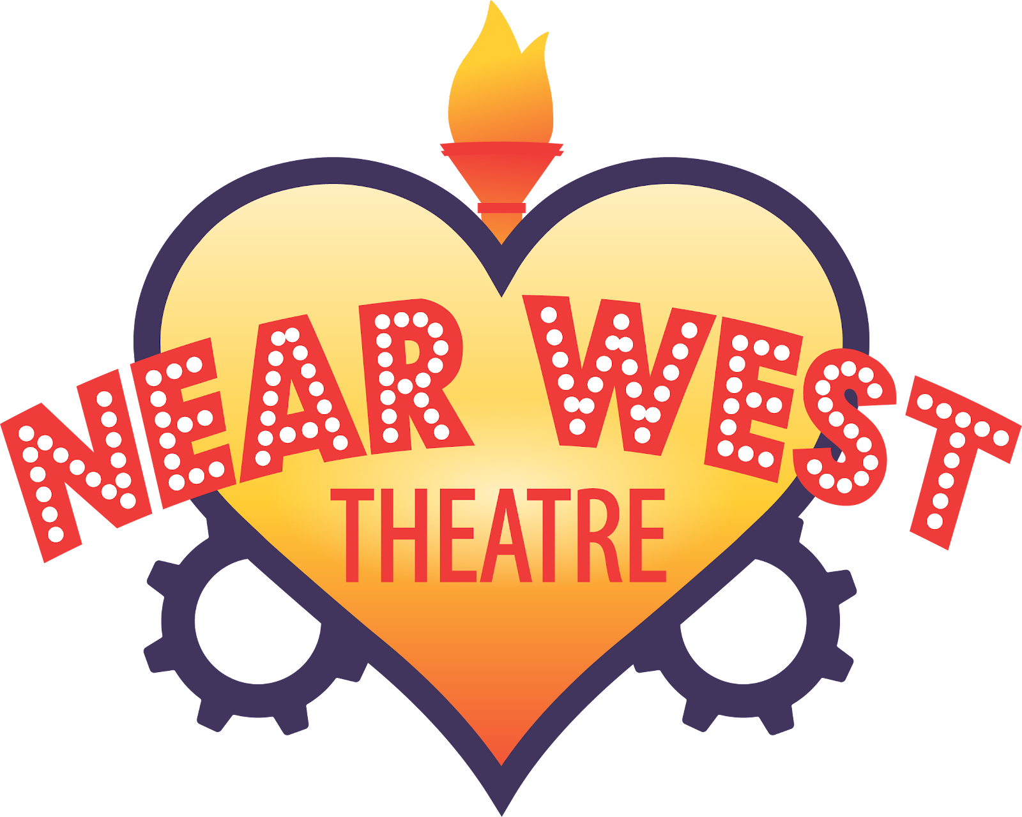

FOR IMMEDIATE RELEASE:
Contact: Hannah Armenta
Engagement Manager
Harmenta@nearwesttheatre.org
216-961-9750

Near West Theatre’s Hairspray Celebrates Joy, Justice, and the Power of Self-Expression

Experience the high-energy Broadway hit in the heart of Gordon Square Arts District

CLEVELAND – October 24, 2025 – Change is in the air this fall at Near West Theatre! The community-driven theatre in the heart of Gordon Square invites audiences to experience the high-energy, feel-good Broadway hit “Hairspray” running November 21 through December 7, 2025. Performances will take place at Near West Theatre’s ADA-compliant venue, located at 6702 Detroit Avenue in the heart of the Gordon Square Arts District. Tickets are $20, with additional Pay What You Choose options available. Visit nearwesttheatre.org or call the Box Office at 216-961-6391, weekdays from 11 a.m. to 4 p.m.

Winner of eight Tony Awards, including Best Musical, “Hairspray” is bursting with laughter, high-energy dance numbers, and irresistible songs. Set in 1962 Baltimore, the story follows Tracy Turnblad, a spirited teen with big dreams (and even bigger hair) who longs to dance on the popular “Corny Collins Show.” When she finally makes it on air, Tracy becomes an overnight sensation, but her newfound fame quickly turns into a call for change as she rallies her community to integrate the TV show and challenge the status quo.

Near West Theatre’s 62-person intergenerational cast brings this beloved musical to life with the theater’s signature joy, authenticity, and heart. For the directing team, “Hairspray’s” message is both timeless and deeply relevant today.

“Sadly, many of the themes of Hairspray are still relevant in 2025,” shares co-director, Kristy Cruz. “The idea that we not only judge people but determine their worth by their size, the color of their skin, their ethnic background, sexual orientation, gender affiliation, or age is still prevalent today. Fortunately, the show’s message of finding the courage to stand for what’s right, loving who you are, finding your community, and knowing your worth are equally as strong.”
The team hopes audiences walk away feeling both uplifted and empowered.

“I think the idea of not being afraid to take up space, use your voice, and advocate for the people in your community whose voices aren’t being heard are all very strong messages in this show, and they’re so applicable to today,” says co-director, Jailyn Harris. “We hope audiences leave feeling a sense of hope, a call to action, and maybe a little relief from the hardship we’re all facing day-to-day. There is room for joy in every resistance and choosing to love and live as your authentic self is more than enough.”

This production is part of Near West Theatre’s 2025-26 Season: “Own Your Own Story,” celebrating voices that dare to be different and communities that come together through the arts.

Near West’s production will feature co-directors and choreographers Kristy Cruz and Jailyn Harris with Music Direction by Dr. Nicholas Klein. The production team also features Lighting Design by David Stoughton, Scenic Design by Cameron Michalak, Costume Design by Vanessa Cook, and Props Master by Annie Krol. Sound Design by James Romeo with Technical Direction by Perren Hedderson. Sound Tech by Joshua Caraballo & Emily Ferrer and Assistant Technical Direction will be offered by Emily Hehnen. Near West’s Production Manager is Michael Stein. “Hairspray” will be Stage Managed by Julie Billinghurst with Assistant Stage Management offered by Maeve Greising.

The talented cast includes (in alphabetical order): Rafael Alacorn, Hannah Armenta, Penny Averre, Jasmine Banes, Isaac Bauman, Bethany Beckham, Symone Bibb, Katie Blume, Emily Brady, Sara Chapman, Christina Ciofani, Timothy Clark, Maddie Cugini, Gabriel Cummings, Brian Currie, Edie Echko-McGory, Emmett Echko-McGory, David Farroni, Joel Fenstermaker, Miyani Figueroa, Emily Fisher, Zoe Frager, Jade-Marie Gantt, Elliott Gates, Blessing Gee, Brady Green, Devon Kress, Dora Lake, Matt Loehrke, Lou Maloney, Maria 'Riri' Matthews, Amaya Mayes, Michael McHargh, Ryleigh McNamee, Lucia Millard, Katie Mounts, Erin Moydell, Ana-Marie Muhammad, Josie O'Leary, Kathryn O'Sullivan, Kai Pennington, Kaleb Pickett, Camila Pinero, Lily Risner, Chris Ross, Christopher Sgarlata, Connor Shelton, Nico Smith, Evan Smittle, Colin Snider, Ava Somich, Neda Spears, Mayela Squires, Nigamanth Sridhar, Viktor Swan, JT Tan, Tyler Thompson, David Turner, Anna Villimonovic, Kellen Williams, Constance Wynn, & Bob Zombar

For additional information including box office information, please visit nearwesttheatre.org. The theatre was constructed as part of the Gordon Square Arts District capital campaign and features climate control and is fully accessible by wheelchair. Little Shop of Horrors is presented through special arrangement with Music Theatre International (MTI).

###

About Near West Theatre
Near West Theatre creates life-changing theatre arts experiences that empower our community. Since 1978, Near West Theatre has been shaping, changing, and saving the lives of children, teens, and adults. The community theater hosts a variety of free community events and free after-school programs to underline its commitment to accessibility for all people. The organization serves people of all ages, but a focus on youth goes back to its founding and continues to this day. www.nearwesttheatre.org. @nearwesttheatre. NWT is grateful to receive financial support from the Ohio Arts Council and Cuyahoga Arts & Culture. For more information, visit nearwesttheatre.org or follow the theatre on Facebook (facebook.com/nearwesttheatre) and Instagram (@nearwesttheatre).

[TOMBSTONE INFO]
“Hairspray”
"And some day, when I take to the floor, the world's gonna wake up and see..."
Fall Intergenerational Production
Runtime: 2 hours and 30 minutes, 15-minute intermission
Book By Thomas Meehan Mark O’Donnell
Music By Marc Shaiman
Lyrics By Marc Shaiman Scott Wittman
Based on the New Line Cinema film, written and directed by John Waters
Hairspray
Is presented through special arrangement with Music Theatre International (MTI).
All authorized performance materials are also supplied by MTI.
www.mtishows.com

Performance Dates
Fri. November 21 - 7:30 PM
Sat. November 22 - 7:30 PM
Fri. November 28 - 7:30 PM
Sat. November 29 - 7:30 PM
Sun. November 30 - 2:00 PM
Thurs. December 4 - 7:30 PM
Fri. December 5 - 7:30 PM
Sat. December 6 - 7:30 PM
Sun. December 7 - 2:00 PM
Suggested Performance Listing
Near West Theatre, 6702 Detroit Ave., Cleveland’s Gordon Square Arts District. Box Office: 216-961-6391 or nearwesttheatre.org. “Hairspray” runs November 21, 22, 28, 29 & December 4, 5, 6 at 7:30 p.m; November 30 & December 7 at 2:00 p.m. General Admission: Tickets $20 with Pay What You Choose options available. Hairspray
Is presented through special arrangement with Music Theatre International (MTI).
All authorized performance materials are also supplied by MTI.
www.mtishows.com

